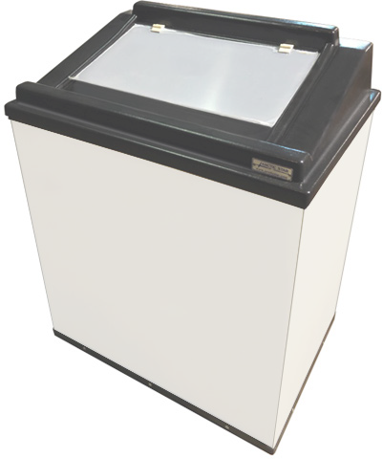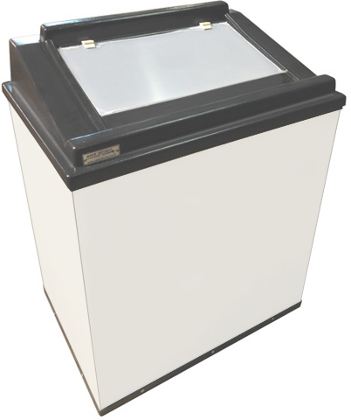

**16**

[**www.arcticstar.com**](http://www.arcticstar.com/)

**TOR-25**

**Hot Tortilla Warmers for greater impulse sales.**

A hot and fresh unit that come with a bunch of big sales.

Voltage 115/60/1 Plug Type NEMA-5-15P Amperes 2.6

Cord Length 6

Temperature 90° to 115°

Length 29”

Width 21”

Height 36”

Length 26”

Width 16”

Depth 16”

Black Black/White

**Get in touch with our Business Manager:**

3540 West Pioneer Parkway, Arlington, TX, 76013

Tel. (817) 274-1396

[info@arcticstar.com](mailto:info@arcticstar.com)

**Product visibility from top**

**Molded durable plastic**

**Features:** hot air flow, self contained, adjustable temperature, clear view plastic doors, surface for branding.

**Color**

**Interior**

**Exterior**

**Electrical Data**